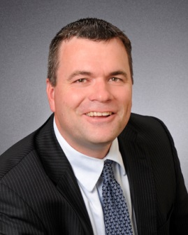
Letter of Expectation
Chief Executive Officer

On behalf of Tohono O’odham Nation Health Care, I welcome you to our team. As a valued team member, your efforts are needed to carry out the Mission, Vision, and Goals of Tohono O’odham Nation Health Care. Our patients and your co-workers expect that you will perform the duties and responsibilities defined in your position description to the best of your abilities. Quality patient care is our priority and as we work together to create a Patient Centered Medical Home, we ask that you communicate efficiently and effectively with everyone you encounter within the community.

The Governing Body, the Medical Staff and myself expect the following from you as you begin your career with us.

As an Employee/Student/Volunteer/Contractor of Tohono O’odham Nation Health Care, I will:

- Not inquire about the financial status of patients in need of emergency care.
- Treat all members of the organization, including those within and outside of Tohono O’odham Nation Health Care, with courtesy, respect, and dignity.
- Exercise tolerance, sincerity, and patience in dealing with others.
- Respect the culture of the Native American patients we serve.
- Follow the Chain of Command until it is exhausted, then I will bring valid concerns regarding patient care, facilities, or other staff to the attention of the Chief Executive Officer, Clinical Director, or other Governing Body members. I will refrain from discussing these issues with others who cannot effect change.
- Assist without delay when called on for emergency situations.
- Follow the policies, procedures, and protocols of Tohono O’odham Nation Health Care and the Tohono O’odham Nation.
- Abide by Ethics and Standards of Conduct rules that include proper conduct on and proper use of tribal property.
- Support the organization's compliance with rules, regulations, and accreditation standards.
- Abide by confidentiality requirements.
- Be mindful of resources and practice my duties in an effective, efficient manner.
- Adhere to and support the Patient Safety/Risk Management requirements of identifying, reporting, and improving patient safety.
- Be a positive reflection of Tohono O’odham Nation Health Care within the realm of my authority.
- Be involved in Tohono O’odham Nation Health Care activities by being an active participant on teams or committees.

__________________________________ _____________________
Employee Signature Date

On behalf of the organization, I hope that your experience with Tohono O’odham Nation Health Care will be long, productive, and career enhancing, and provide you with a sense of belonging and dedication to the Native American people we serve. The strength of Tohono O’odham Nation Health Care lies with its employees.
Troy Klarkowski
Tohono O’odham Nation Health Care
Interim Chief Executive Officer

